# 基于Java的录音机（Rest API的页面操作）

## 新建Spring Boot项目

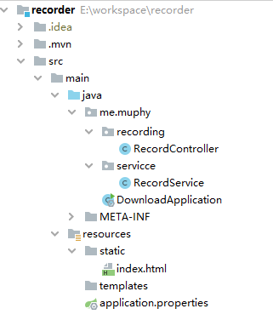

## pop.xml

<?xml version="1.0" encoding="UTF-8"?>

<project xmlns="http://maven.apache.org/POM/4.0.0" xmlns:xsi="http://www.w3.org/2001/XMLSchema-instance"

xsi:schemaLocation="http://maven.apache.org/POM/4.0.0 https://maven.apache.org/xsd/maven-4.0.0.xsd">

<modelVersion>4.0.0</modelVersion>

<parent>

<groupId>org.springframework.boot</groupId>

<artifactId>spring-boot-starter-parent</artifactId>

<version>2.2.5.RELEASE</version>

<relativePath/> <!-- lookup parent from repository -->

</parent>

<groupId>me.muphy</groupId>

<artifactId>recorder</artifactId>

<version>0.0.1-SNAPSHOT</version>

<name>recorder</name>

<description>Demo project for Spring Boot</description>

<properties>

<java.version>1.8</java.version>

</properties>

<dependencies>

<dependency>

<groupId>org.springframework.boot</groupId>

<artifactId>spring-boot-starter-web</artifactId>

</dependency>

<dependency>

<groupId>org.springframework.boot</groupId>

<artifactId>spring-boot-starter-test</artifactId>

<scope>test</scope>

<exclusions>

<exclusion>

<groupId>org.junit.vintage</groupId>

<artifactId>junit-vintage-engine</artifactId>

</exclusion>

</exclusions>

</dependency>

</dependencies>

<build>

<plugins>

<plugin>

<groupId>org.springframework.boot</groupId>

<artifactId>spring-boot-maven-plugin</artifactId>

</plugin>

</plugins>

</build>

</project>

## application.properties

server.port=8080

#录音

record.time.default=3600

record.path=E:/workspace/share/

## index.html

<!DOCTYPE html>

<html lang="en">

<head>

<meta charset="UTF-8">

<title>莫非录音机</title>

</head>

<body>

<div>

<form action="/record/start" method="get">

<div>请输入需要录音的时间(s):<input type="number" name="t" id="t" max="7200" min="0"><button type="submit">开始录音</button></div>

</form>

</div>

</body>

</html>

## RecordController.java

package me.muphy.recording;

import me.muphy.servicce.RecordService;

import org.springframework.beans.factory.annotation.Autowired;

import org.springframework.beans.factory.annotation.Value;

import org.springframework.web.bind.annotation.GetMapping;

import org.springframework.web.bind.annotation.RequestMapping;

import org.springframework.web.bind.annotation.RestController;

import javax.servlet.http.HttpServletRequest;

import javax.sound.sampled.*;

import java.io.*;

@RestController

@RequestMapping("/record")

public class RecordController {

@Autowired

private RecordService recordService;

@Value("${download.url:http://(ip):(port)}")

private String downloadUrl;

@GetMapping("/start")

public String startRecord(int t, HttpServletRequest request) {

String msg = recordService.start(t);

String ip = request.getServerName();

int port = request.getServerPort();

return "<span>" + msg + "</span><br><span><a href=\"" + downloadUrl.replace("(ip)", ip).replace("(port)", port + "") + "/record/stop\" >点击停止录音</a></span>";

}

@GetMapping("/stop")

public String stopRecord(HttpServletRequest request) {

String msg = recordService.stop();

String ip = request.getServerName();

int port = request.getServerPort();

return "<span>" + msg + "</span>";

}

}

## RecordApplication.java

package me.muphy;

import org.springframework.boot.SpringApplication;

import org.springframework.boot.autoconfigure.SpringBootApplication;

@SpringBootApplication

public class RecordApplication {

public static void main(String[] args) {

SpringApplication.run(RecordApplication.class, args);

}

}

## 启动项目

